Multiple Linear Regression¶

Housing Case Study¶

Problem Statement:¶
Consider a real estate company that has a dataset containing the prices of properties in the Delhi region. It wishes to use the data to optimise the sale prices of the properties based on important factors such as area, bedrooms, parking, etc.
Essentially, the company wants —
- To identify the variables affecting house prices, e.g. area, number of rooms, bathrooms, etc.
- To create a linear model that quantitatively relates house prices with variables such as number of rooms, area, number of bathrooms, etc.
- To know the accuracy of the model, i.e. how well these variables can predict house prices.
So interpretation is important!

Step 1: Reading and Understanding the Data¶
Let us first import NumPy and Pandas and read the housing dataset
In [1]:
# Supress Warnings

import warnings
warnings.filterwarnings('ignore')
In [2]:
import numpy as np
import pandas as pd
In [3]:
housing = pd.read_csv("Housing.csv")
In [4]:
# Check the head of the dataset
housing.head()
Out[4]:
 | price | area | bedrooms | bathrooms | stories | mainroad | guestroom | basement | hotwaterheating | airconditioning | parking | prefarea | furnishingstatus
0 | 13300000 | 7420 | 4 | 2 | 3 | yes | no | no | no | yes | 2 | yes | furnished
1 | 12250000 | 8960 | 4 | 4 | 4 | yes | no | no | no | yes | 3 | no | furnished
2 | 12250000 | 9960 | 3 | 2 | 2 | yes | no | yes | no | no | 2 | yes | semi-furnished
3 | 12215000 | 7500 | 4 | 2 | 2 | yes | no | yes | no | yes | 3 | yes | furnished
4 | 11410000 | 7420 | 4 | 1 | 2 | yes | yes | yes | no | yes | 2 | no | furnished
Inspect the various aspects of the housing dataframe
In [5]:
housing.shape
Out[5]:
(545, 13)
In [6]:
housing.info()
<class 'pandas.core.frame.DataFrame'>
RangeIndex: 545 entries, 0 to 544
Data columns (total 13 columns):
price 545 non-null int64
area 545 non-null int64
bedrooms 545 non-null int64
bathrooms 545 non-null int64
stories 545 non-null int64
mainroad 545 non-null object
guestroom 545 non-null object
basement 545 non-null object
hotwaterheating 545 non-null object
airconditioning 545 non-null object
parking 545 non-null int64
prefarea 545 non-null object
furnishingstatus 545 non-null object
dtypes: int64(6), object(7)
memory usage: 55.4+ KB
In [7]:
housing.describe()
Out[7]:
 | price | area | bedrooms | bathrooms | stories | parking
count | 5.450000e+02 | 545.000000 | 545.000000 | 545.000000 | 545.000000 | 545.000000
mean | 4.766729e+06 | 5150.541284 | 2.965138 | 1.286239 | 1.805505 | 0.693578
std | 1.870440e+06 | 2170.141023 | 0.738064 | 0.502470 | 0.867492 | 0.861586
min | 1.750000e+06 | 1650.000000 | 1.000000 | 1.000000 | 1.000000 | 0.000000
25% | 3.430000e+06 | 3600.000000 | 2.000000 | 1.000000 | 1.000000 | 0.000000
50% | 4.340000e+06 | 4600.000000 | 3.000000 | 1.000000 | 2.000000 | 0.000000
75% | 5.740000e+06 | 6360.000000 | 3.000000 | 2.000000 | 2.000000 | 1.000000
max | 1.330000e+07 | 16200.000000 | 6.000000 | 4.000000 | 4.000000 | 3.000000

Step 2: Visualising the Data¶
Let's now spend some time doing what is arguably the most important step - understanding the data.
- If there is some obvious multicollinearity going on, this is the first place to catch it
- Here's where you'll also identify if some predictors directly have a strong association with the outcome variable
We'll visualise our data using matplotlib and seaborn.
In [8]:
import matplotlib.pyplot as plt
import seaborn as sns

Visualising Numeric Variables¶
Let's make a pairplot of all the numeric variables
In [9]:
sns.pairplot(housing)
plt.show()
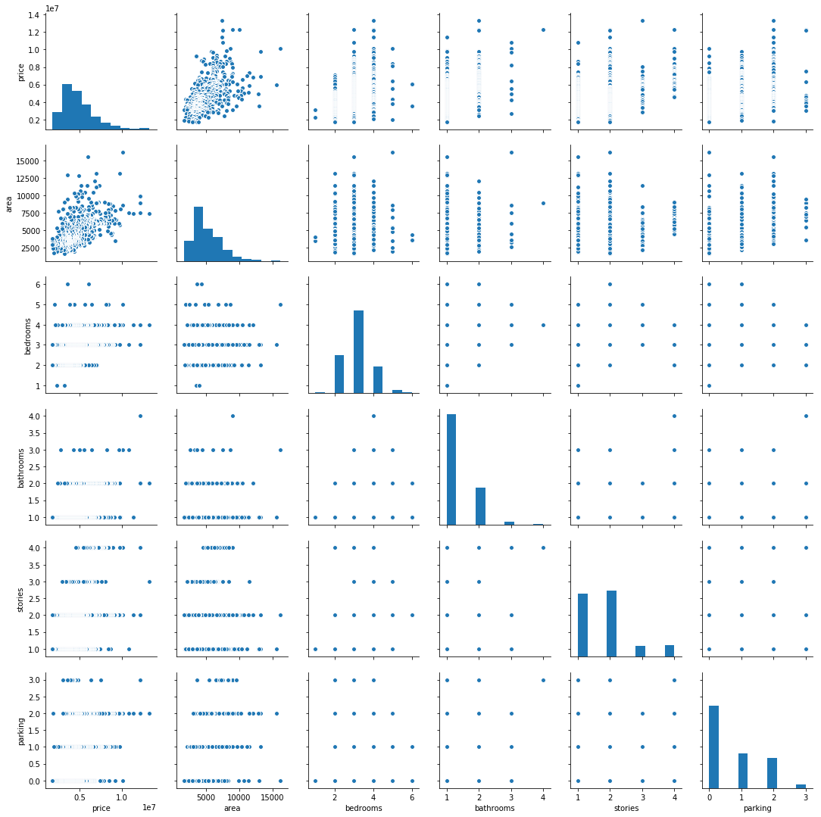

Visualising Categorical Variables¶
As you might have noticed, there are a few categorical variables as well. Let's make a boxplot for some of these variables.
In [10]:
plt.figure(figsize=(20, 12))
plt.subplot(2,3,1)
sns.boxplot(x = 'mainroad', y = 'price', data = housing)
plt.subplot(2,3,2)
sns.boxplot(x = 'guestroom', y = 'price', data = housing)
plt.subplot(2,3,3)
sns.boxplot(x = 'basement', y = 'price', data = housing)
plt.subplot(2,3,4)
sns.boxplot(x = 'hotwaterheating', y = 'price', data = housing)
plt.subplot(2,3,5)
sns.boxplot(x = 'airconditioning', y = 'price', data = housing)
plt.subplot(2,3,6)
sns.boxplot(x = 'furnishingstatus', y = 'price', data = housing)
plt.show()
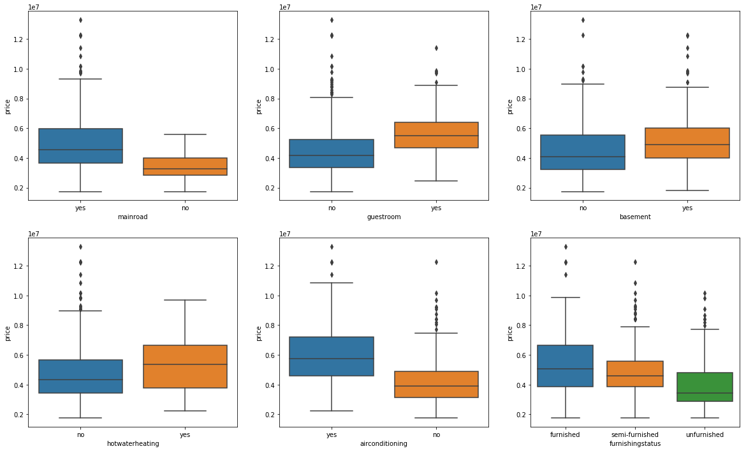
We can also visualise some of these categorical features parallely by using the hue argument. Below is the plot for furnishingstatus with airconditioning as the hue.
In [11]:
plt.figure(figsize = (10, 5))
sns.boxplot(x = 'furnishingstatus', y = 'price', hue = 'airconditioning', data = housing)
plt.show()
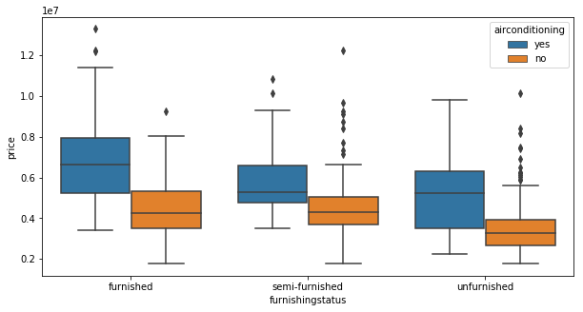

Step 3: Data Preparation¶
- You can see that your dataset has many columns with values as 'Yes' or 'No'.
- But in order to fit a regression line, we would need numerical values and not string. Hence, we need to convert them to 1s and 0s, where 1 is a 'Yes' and 0 is a 'No'.
In [12]:
# List of variables to map

varlist = ['mainroad', 'guestroom', 'basement', 'hotwaterheating', 'airconditioning', 'prefarea']

# Defining the map function
def binary_map(x):
return x.map({'yes': 1, "no": 0})

# Applying the function to the housing list
housing[varlist] = housing[varlist].apply(binary_map)
In [13]:
# Check the housing dataframe now

housing.head()
Out[13]:
 | price | area | bedrooms | bathrooms | stories | mainroad | guestroom | basement | hotwaterheating | airconditioning | parking | prefarea | furnishingstatus
0 | 13300000 | 7420 | 4 | 2 | 3 | 1 | 0 | 0 | 0 | 1 | 2 | 1 | furnished
1 | 12250000 | 8960 | 4 | 4 | 4 | 1 | 0 | 0 | 0 | 1 | 3 | 0 | furnished
2 | 12250000 | 9960 | 3 | 2 | 2 | 1 | 0 | 1 | 0 | 0 | 2 | 1 | semi-furnished
3 | 12215000 | 7500 | 4 | 2 | 2 | 1 | 0 | 1 | 0 | 1 | 3 | 1 | furnished
4 | 11410000 | 7420 | 4 | 1 | 2 | 1 | 1 | 1 | 0 | 1 | 2 | 0 | furnished

Dummy Variables¶
The variable furnishingstatus has three levels. We need to convert these levels into integer as well.
For this, we will use something called dummy variables.
In [14]:
# Get the dummy variables for the feature 'furnishingstatus' and store it in a new variable - 'status'
status = pd.get_dummies(housing['furnishingstatus'])
In [15]:
# Check what the dataset 'status' looks like
status.head()
Out[15]:
 | furnished | semi-furnished | unfurnished
0 | 1 | 0 | 0
1 | 1 | 0 | 0
2 | 0 | 1 | 0
3 | 1 | 0 | 0
4 | 1 | 0 | 0
Now, you don't need three columns. You can drop the furnished column, as the type of furnishing can be identified with just the last two columns where —
- 00 will correspond to furnished
- 01 will correspond to unfurnished
- 10 will correspond to semi-furnished
In [16]:
# Let's drop the first column from status df using 'drop_first = True'

status = pd.get_dummies(housing['furnishingstatus'], drop_first = True)
In [17]:
# Add the results to the original housing dataframe

housing = pd.concat([housing, status], axis = 1)
In [18]:
# Now let's see the head of our dataframe.

housing.head()
Out[18]:
 | price | area | bedrooms | bathrooms | stories | mainroad | guestroom | basement | hotwaterheating | airconditioning | parking | prefarea | furnishingstatus | semi-furnished | unfurnished
0 | 13300000 | 7420 | 4 | 2 | 3 | 1 | 0 | 0 | 0 | 1 | 2 | 1 | furnished | 0 | 0
1 | 12250000 | 8960 | 4 | 4 | 4 | 1 | 0 | 0 | 0 | 1 | 3 | 0 | furnished | 0 | 0
2 | 12250000 | 9960 | 3 | 2 | 2 | 1 | 0 | 1 | 0 | 0 | 2 | 1 | semi-furnished | 1 | 0
3 | 12215000 | 7500 | 4 | 2 | 2 | 1 | 0 | 1 | 0 | 1 | 3 | 1 | furnished | 0 | 0
4 | 11410000 | 7420 | 4 | 1 | 2 | 1 | 1 | 1 | 0 | 1 | 2 | 0 | furnished | 0 | 0
In [19]:
# Drop 'furnishingstatus' as we have created the dummies for it

housing.drop(['furnishingstatus'], axis = 1, inplace = True)
In [20]:
housing.head()
Out[20]:
 | price | area | bedrooms | bathrooms | stories | mainroad | guestroom | basement | hotwaterheating | airconditioning | parking | prefarea | semi-furnished | unfurnished
0 | 13300000 | 7420 | 4 | 2 | 3 | 1 | 0 | 0 | 0 | 1 | 2 | 1 | 0 | 0
1 | 12250000 | 8960 | 4 | 4 | 4 | 1 | 0 | 0 | 0 | 1 | 3 | 0 | 0 | 0
2 | 12250000 | 9960 | 3 | 2 | 2 | 1 | 0 | 1 | 0 | 0 | 2 | 1 | 1 | 0
3 | 12215000 | 7500 | 4 | 2 | 2 | 1 | 0 | 1 | 0 | 1 | 3 | 1 | 0 | 0
4 | 11410000 | 7420 | 4 | 1 | 2 | 1 | 1 | 1 | 0 | 1 | 2 | 0 | 0 | 0

Step 4: Splitting the Data into Training and Testing Sets¶
As you know, the first basic step for regression is performing a train-test split.
In [21]:
from sklearn.model_selection import train_test_split

# We specify this so that the train and test data set always have the same rows, respectively
np.random.seed(0)
df_train, df_test = train_test_split(housing, train_size = 0.7, test_size = 0.3, random_state = 100)

Rescaling the Features¶
As you saw in the demonstration for Simple Linear Regression, scaling doesn't impact your model. Here we can see that except for area, all the columns have small integer values. So it is extremely important to rescale the variables so that they have a comparable scale. If we don't have comparable scales, then some of the coefficients as obtained by fitting the regression model might be very large or very small as compared to the other coefficients. This might become very annoying at the time of model evaluation. So it is advised to use standardization or normalization so that the units of the coefficients obtained are all on the same scale. As you know, there are two common ways of rescaling:
- Min-Max scaling
- Standardisation (mean-0, sigma-1)
This time, we will use MinMax scaling.
In [22]:
from sklearn.preprocessing import MinMaxScaler
In [23]:
scaler = MinMaxScaler()
In [24]:
# Apply scaler() to all the columns except the 'yes-no' and 'dummy' variables
num_vars = ['area', 'bedrooms', 'bathrooms', 'stories', 'parking','price']

df_train[num_vars] = scaler.fit_transform(df_train[num_vars])
In [25]:
df_train.head()
Out[25]:
 | price | area | bedrooms | bathrooms | stories | mainroad | guestroom | basement | hotwaterheating | airconditioning | parking | prefarea | semi-furnished | unfurnished
359 | 0.169697 | 0.155227 | 0.4 | 0.0 | 0.000000 | 1 | 0 | 0 | 0 | 0 | 0.333333 | 0 | 0 | 1
19 | 0.615152 | 0.403379 | 0.4 | 0.5 | 0.333333 | 1 | 0 | 0 | 0 | 1 | 0.333333 | 1 | 1 | 0
159 | 0.321212 | 0.115628 | 0.4 | 0.5 | 0.000000 | 1 | 1 | 1 | 0 | 1 | 0.000000 | 0 | 0 | 0
35 | 0.548133 | 0.454417 | 0.4 | 0.5 | 1.000000 | 1 | 0 | 0 | 0 | 1 | 0.666667 | 0 | 0 | 0
28 | 0.575758 | 0.538015 | 0.8 | 0.5 | 0.333333 | 1 | 0 | 1 | 1 | 0 | 0.666667 | 0 | 0 | 1
In [26]:
df_train.describe()
Out[26]:
 | price | area | bedrooms | bathrooms | stories | mainroad | guestroom | basement | hotwaterheating | airconditioning | parking | prefarea | semi-furnished | unfurnished
count | 381.000000 | 381.000000 | 381.000000 | 381.000000 | 381.000000 | 381.000000 | 381.000000 | 381.000000 | 381.000000 | 381.000000 | 381.000000 | 381.000000 | 381.000000 | 381.000000
mean | 0.260333 | 0.288710 | 0.386352 | 0.136483 | 0.268591 | 0.855643 | 0.170604 | 0.351706 | 0.052493 | 0.299213 | 0.242345 | 0.233596 | 0.414698 | 0.325459
std | 0.157607 | 0.181420 | 0.147336 | 0.237325 | 0.295001 | 0.351913 | 0.376657 | 0.478131 | 0.223313 | 0.458515 | 0.285933 | 0.423674 | 0.493318 | 0.469162
min | 0.000000 | 0.000000 | 0.000000 | 0.000000 | 0.000000 | 0.000000 | 0.000000 | 0.000000 | 0.000000 | 0.000000 | 0.000000 | 0.000000 | 0.000000 | 0.000000
25% | 0.151515 | 0.155227 | 0.200000 | 0.000000 | 0.000000 | 1.000000 | 0.000000 | 0.000000 | 0.000000 | 0.000000 | 0.000000 | 0.000000 | 0.000000 | 0.000000
50% | 0.221212 | 0.234424 | 0.400000 | 0.000000 | 0.333333 | 1.000000 | 0.000000 | 0.000000 | 0.000000 | 0.000000 | 0.000000 | 0.000000 | 0.000000 | 0.000000
75% | 0.345455 | 0.398099 | 0.400000 | 0.500000 | 0.333333 | 1.000000 | 0.000000 | 1.000000 | 0.000000 | 1.000000 | 0.333333 | 0.000000 | 1.000000 | 1.000000
max | 1.000000 | 1.000000 | 1.000000 | 1.000000 | 1.000000 | 1.000000 | 1.000000 | 1.000000 | 1.000000 | 1.000000 | 1.000000 | 1.000000 | 1.000000 | 1.000000
In [27]:
# Let's check the correlation coefficients to see which variables are highly correlated

plt.figure(figsize = (16, 10))
sns.heatmap(df_train.corr(), annot = True, cmap="YlGnBu")
plt.show()
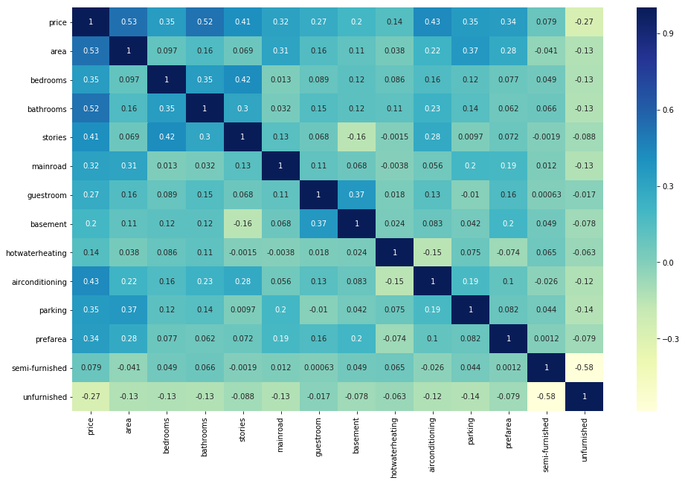
As you might have noticed, area seems to the correlated to price the most. Let's see a pairplot for area vs price.
In [28]:
plt.figure(figsize=[6,6])
plt.scatter(df_train.area, df_train.price)
plt.show()
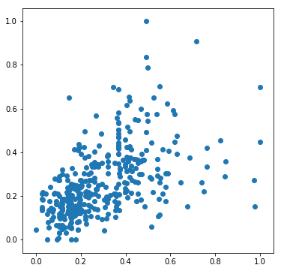
So, we pick area as the first variable and we'll try to fit a regression line to that.

Dividing into X and Y sets for the model building¶
In [29]:
y_train = df_train.pop('price')
X_train = df_train

Step 5: Building a linear model¶
Fit a regression line through the training data using statsmodels. Remember that in statsmodels, you need to explicitly fit a constant using sm.add_constant(X) because if we don't perform this step, statsmodels fits a regression line passing through the origin, by default.
In [30]:
import statsmodels.api as sm

# Add a constant
X_train_lm = sm.add_constant(X_train[['area']])

# Create a first fitted model
lr = sm.OLS(y_train, X_train_lm).fit()
In [31]:
# Check the parameters obtained

lr.params
Out[31]:
const 0.126894
area 0.462192
dtype: float64
In [32]:
# Let's visualise the data with a scatter plot and the fitted regression line
plt.scatter(X_train_lm.iloc[:, 1], y_train)
plt.plot(X_train_lm.iloc[:, 1], 0.127 + 0.462*X_train_lm.iloc[:, 1], 'r')
plt.show()
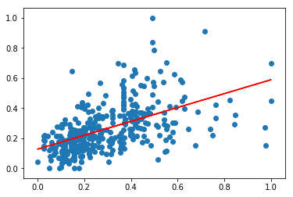
In [33]:
# Print a summary of the linear regression model obtained
print(lr.summary())
OLS Regression Results
==============================================================================
Dep. Variable: price R-squared: 0.283
Model: OLS Adj. R-squared: 0.281
Method: Least Squares F-statistic: 149.6
Date: Tue, 09 Oct 2018 Prob (F-statistic): 3.15e-29
Time: 13:02:46 Log-Likelihood: 227.23
No. Observations: 381 AIC: -450.5
Df Residuals: 379 BIC: -442.6
Df Model: 1
Covariance Type: nonrobust
==============================================================================
coef std err t P>|t| [0.025 0.975]
------------------------------------------------------------------------------
const 0.1269 0.013 9.853 0.000 0.102 0.152
area 0.4622 0.038 12.232 0.000 0.388 0.536
==============================================================================
Omnibus: 67.313 Durbin-Watson: 2.018
Prob(Omnibus): 0.000 Jarque-Bera (JB): 143.063
Skew: 0.925 Prob(JB): 8.59e-32
Kurtosis: 5.365 Cond. No. 5.99
==============================================================================

Warnings:
[1] Standard Errors assume that the covariance matrix of the errors is correctly specified.

Adding another variable¶
The R-squared value obtained is 0.283. Since we have so many variables, we can clearly do better than this. So let's go ahead and add the second most highly correlated variable, i.e. bathrooms.
In [34]:
# Assign all the feature variables to X
X_train_lm = X_train[['area', 'bathrooms']]
In [35]:
# Build a linear model

import statsmodels.api as sm
X_train_lm = sm.add_constant(X_train_lm)

lr = sm.OLS(y_train, X_train_lm).fit()

lr.params
Out[35]:
const 0.104589
area 0.398396
bathrooms 0.298374
dtype: float64
In [36]:
# Check the summary
print(lr.summary())
OLS Regression Results
==============================================================================
Dep. Variable: price R-squared: 0.480
Model: OLS Adj. R-squared: 0.477
Method: Least Squares F-statistic: 174.1
Date: Tue, 09 Oct 2018 Prob (F-statistic): 2.51e-54
Time: 13:02:47 Log-Likelihood: 288.24
No. Observations: 381 AIC: -570.5
Df Residuals: 378 BIC: -558.6
Df Model: 2
Covariance Type: nonrobust
==============================================================================
coef std err t P>|t| [0.025 0.975]
------------------------------------------------------------------------------
const 0.1046 0.011 9.384 0.000 0.083 0.127
area 0.3984 0.033 12.192 0.000 0.334 0.463
bathrooms 0.2984 0.025 11.945 0.000 0.249 0.347
==============================================================================
Omnibus: 62.839 Durbin-Watson: 2.157
Prob(Omnibus): 0.000 Jarque-Bera (JB): 168.790
Skew: 0.784 Prob(JB): 2.23e-37
Kurtosis: 5.859 Cond. No. 6.17
==============================================================================

Warnings:
[1] Standard Errors assume that the covariance matrix of the errors is correctly specified.
We have clearly improved the model as the value of adjusted R-squared as its value has gone up to 0.477 from 0.281. Let's go ahead and add another variable, bedrooms.
In [37]:
# Assign all the feature variables to X
X_train_lm = X_train[['area', 'bathrooms','bedrooms']]
In [38]:
# Build a linear model

import statsmodels.api as sm
X_train_lm = sm.add_constant(X_train_lm)

lr = sm.OLS(y_train, X_train_lm).fit()

lr.params
Out[38]:
const 0.041352
area 0.392211
bathrooms 0.259978
bedrooms 0.181863
dtype: float64
In [39]:
# Print the summary of the model

print(lr.summary())
OLS Regression Results
==============================================================================
Dep. Variable: price R-squared: 0.505
Model: OLS Adj. R-squared: 0.501
Method: Least Squares F-statistic: 128.2
Date: Tue, 09 Oct 2018 Prob (F-statistic): 3.12e-57
Time: 13:02:47 Log-Likelihood: 297.76
No. Observations: 381 AIC: -587.5
Df Residuals: 377 BIC: -571.7
Df Model: 3
Covariance Type: nonrobust
==============================================================================
coef std err t P>|t| [0.025 0.975]
------------------------------------------------------------------------------
const 0.0414 0.018 2.292 0.022 0.006 0.077
area 0.3922 0.032 12.279 0.000 0.329 0.455
bathrooms 0.2600 0.026 10.033 0.000 0.209 0.311
bedrooms 0.1819 0.041 4.396 0.000 0.101 0.263
==============================================================================
Omnibus: 50.037 Durbin-Watson: 2.136
Prob(Omnibus): 0.000 Jarque-Bera (JB): 124.806
Skew: 0.648 Prob(JB): 7.92e-28
Kurtosis: 5.487 Cond. No. 8.87
==============================================================================

Warnings:
[1] Standard Errors assume that the covariance matrix of the errors is correctly specified.
We have improved the adjusted R-squared again. Now let's go ahead and add all the feature variables.

Adding all the variables to the model¶
In [40]:
# Check all the columns of the dataframe

housing.columns
Out[40]:
Index(['price', 'area', 'bedrooms', 'bathrooms', 'stories', 'mainroad',
'guestroom', 'basement', 'hotwaterheating', 'airconditioning',
'parking', 'prefarea', 'semi-furnished', 'unfurnished'],
dtype='object')
In [41]:
#Build a linear model

import statsmodels.api as sm
X_train_lm = sm.add_constant(X_train)

lr_1 = sm.OLS(y_train, X_train_lm).fit()

lr_1.params
Out[41]:
const 0.020033
area 0.234664
bedrooms 0.046735
bathrooms 0.190823
stories 0.108516
mainroad 0.050441
guestroom 0.030428
basement 0.021595
hotwaterheating 0.084863
airconditioning 0.066881
parking 0.060735
prefarea 0.059428
semi-furnished 0.000921
unfurnished -0.031006
dtype: float64
In [42]:
print(lr_1.summary())
OLS Regression Results
==============================================================================
Dep. Variable: price R-squared: 0.681
Model: OLS Adj. R-squared: 0.670
Method: Least Squares F-statistic: 60.40
Date: Tue, 09 Oct 2018 Prob (F-statistic): 8.83e-83
Time: 13:02:47 Log-Likelihood: 381.79
No. Observations: 381 AIC: -735.6
Df Residuals: 367 BIC: -680.4
Df Model: 13
Covariance Type: nonrobust
===================================================================================
coef std err t P>|t| [0.025 0.975]
-----------------------------------------------------------------------------------
const 0.0200 0.021 0.955 0.340 -0.021 0.061
area 0.2347 0.030 7.795 0.000 0.175 0.294
bedrooms 0.0467 0.037 1.267 0.206 -0.026 0.119
bathrooms 0.1908 0.022 8.679 0.000 0.148 0.234
stories 0.1085 0.019 5.661 0.000 0.071 0.146
mainroad 0.0504 0.014 3.520 0.000 0.022 0.079
guestroom 0.0304 0.014 2.233 0.026 0.004 0.057
basement 0.0216 0.011 1.943 0.053 -0.000 0.043
hotwaterheating 0.0849 0.022 3.934 0.000 0.042 0.127
airconditioning 0.0669 0.011 5.899 0.000 0.045 0.089
parking 0.0607 0.018 3.365 0.001 0.025 0.096
prefarea 0.0594 0.012 5.040 0.000 0.036 0.083
semi-furnished 0.0009 0.012 0.078 0.938 -0.022 0.024
unfurnished -0.0310 0.013 -2.440 0.015 -0.056 -0.006
==============================================================================
Omnibus: 93.687 Durbin-Watson: 2.093
Prob(Omnibus): 0.000 Jarque-Bera (JB): 304.917
Skew: 1.091 Prob(JB): 6.14e-67
Kurtosis: 6.801 Cond. No. 14.6
==============================================================================

Warnings:
[1] Standard Errors assume that the covariance matrix of the errors is correctly specified.
Looking at the p-values, it looks like some of the variables aren't really significant (in the presence of other variables).
Maybe we could drop some?
We could simply drop the variable with the highest, non-significant p value. A better way would be to supplement this with the VIF information.

Checking VIF¶
Variance Inflation Factor or VIF, gives a basic quantitative idea about how much the feature variables are correlated with each other. It is an extremely important parameter to test our linear model. The formula for calculating VIF is:

VIFi=11−Ri2VIFi=11−Ri2 ¶
In [43]:
# Check for the VIF values of the feature variables.
from statsmodels.stats.outliers_influence import variance_inflation_factor
In [44]:
# Create a dataframe that will contain the names of all the feature variables and their respective VIFs
vif = pd.DataFrame()
vif['Features'] = X_train.columns
vif['VIF'] = [variance_inflation_factor(X_train.values, i) for i in range(X_train.shape[1])]
vif['VIF'] = round(vif['VIF'], 2)
vif = vif.sort_values(by = "VIF", ascending = False)
vif
Out[44]:
 | Features | VIF
1 | bedrooms | 7.33
4 | mainroad | 6.02
0 | area | 4.67
3 | stories | 2.70
11 | semi-furnished | 2.19
9 | parking | 2.12
6 | basement | 2.02
12 | unfurnished | 1.82
8 | airconditioning | 1.77
2 | bathrooms | 1.67
10 | prefarea | 1.51
5 | guestroom | 1.47
7 | hotwaterheating | 1.14
We generally want a VIF that is less than 5. So there are clearly some variables we need to drop.

Dropping the variable and updating the model¶
As you can see from the summary and the VIF dataframe, some variables are still insignificant. One of these variables is, semi-furnished as it has a very high p-value of 0.938. Let's go ahead and drop this variables
In [45]:
# Dropping highly correlated variables and insignificant variables

X = X_train.drop('semi-furnished', 1,)
In [46]:
# Build a third fitted model
X_train_lm = sm.add_constant(X)

lr_2 = sm.OLS(y_train, X_train_lm).fit()
In [47]:
# Print the summary of the model
print(lr_2.summary())
OLS Regression Results
==============================================================================
Dep. Variable: price R-squared: 0.681
Model: OLS Adj. R-squared: 0.671
Method: Least Squares F-statistic: 65.61
Date: Tue, 09 Oct 2018 Prob (F-statistic): 1.07e-83
Time: 13:02:48 Log-Likelihood: 381.79
No. Observations: 381 AIC: -737.6
Df Residuals: 368 BIC: -686.3
Df Model: 12
Covariance Type: nonrobust
===================================================================================
coef std err t P>|t| [0.025 0.975]
-----------------------------------------------------------------------------------
const 0.0207 0.019 1.098 0.273 -0.016 0.058
area 0.2344 0.030 7.845 0.000 0.176 0.293
bedrooms 0.0467 0.037 1.268 0.206 -0.026 0.119
bathrooms 0.1909 0.022 8.697 0.000 0.148 0.234
stories 0.1085 0.019 5.669 0.000 0.071 0.146
mainroad 0.0504 0.014 3.524 0.000 0.022 0.079
guestroom 0.0304 0.014 2.238 0.026 0.004 0.057
basement 0.0216 0.011 1.946 0.052 -0.000 0.043
hotwaterheating 0.0849 0.022 3.941 0.000 0.043 0.127
airconditioning 0.0668 0.011 5.923 0.000 0.045 0.089
parking 0.0608 0.018 3.372 0.001 0.025 0.096
prefarea 0.0594 0.012 5.046 0.000 0.036 0.083
unfurnished -0.0316 0.010 -3.096 0.002 -0.052 -0.012
==============================================================================
Omnibus: 93.538 Durbin-Watson: 2.092
Prob(Omnibus): 0.000 Jarque-Bera (JB): 303.844
Skew: 1.090 Prob(JB): 1.05e-66
Kurtosis: 6.794 Cond. No. 14.1
==============================================================================

Warnings:
[1] Standard Errors assume that the covariance matrix of the errors is correctly specified.
In [48]:
# Calculate the VIFs again for the new model

vif = pd.DataFrame()
vif['Features'] = X.columns
vif['VIF'] = [variance_inflation_factor(X.values, i) for i in range(X.shape[1])]
vif['VIF'] = round(vif['VIF'], 2)
vif = vif.sort_values(by = "VIF", ascending = False)
vif
Out[48]:
 | Features | VIF
1 | bedrooms | 6.59
4 | mainroad | 5.68
0 | area | 4.67
3 | stories | 2.69
9 | parking | 2.12
6 | basement | 2.01
8 | airconditioning | 1.77
2 | bathrooms | 1.67
10 | prefarea | 1.51
5 | guestroom | 1.47
11 | unfurnished | 1.40
7 | hotwaterheating | 1.14

Dropping the Variable and Updating the Model¶
As you can notice some of the variable have high VIF values as well as high p-values. Such variables are insignificant and should be dropped.
As you might have noticed, the variable bedroom has a significantly high VIF (6.6) and a high p-value (0.206) as well. Hence, this variable isn't of much use and should be dropped.
In [49]:
# Dropping highly correlated variables and insignificant variables
X = X.drop('bedrooms', 1)
In [50]:
# Build a second fitted model
X_train_lm = sm.add_constant(X)

lr_3 = sm.OLS(y_train, X_train_lm).fit()
In [51]:
# Print the summary of the model

print(lr_3.summary())
OLS Regression Results
==============================================================================
Dep. Variable: price R-squared: 0.680
Model: OLS Adj. R-squared: 0.671
Method: Least Squares F-statistic: 71.31
Date: Tue, 09 Oct 2018 Prob (F-statistic): 2.73e-84
Time: 13:02:48 Log-Likelihood: 380.96
No. Observations: 381 AIC: -737.9
Df Residuals: 369 BIC: -690.6
Df Model: 11
Covariance Type: nonrobust
===================================================================================
coef std err t P>|t| [0.025 0.975]
-----------------------------------------------------------------------------------
const 0.0357 0.015 2.421 0.016 0.007 0.065
area 0.2347 0.030 7.851 0.000 0.176 0.294
bathrooms 0.1965 0.022 9.132 0.000 0.154 0.239
stories 0.1178 0.018 6.654 0.000 0.083 0.153
mainroad 0.0488 0.014 3.423 0.001 0.021 0.077
guestroom 0.0301 0.014 2.211 0.028 0.003 0.057
basement 0.0239 0.011 2.183 0.030 0.002 0.045
hotwaterheating 0.0864 0.022 4.014 0.000 0.044 0.129
airconditioning 0.0665 0.011 5.895 0.000 0.044 0.089
parking 0.0629 0.018 3.501 0.001 0.028 0.098
prefarea 0.0596 0.012 5.061 0.000 0.036 0.083
unfurnished -0.0323 0.010 -3.169 0.002 -0.052 -0.012
==============================================================================
Omnibus: 97.661 Durbin-Watson: 2.097
Prob(Omnibus): 0.000 Jarque-Bera (JB): 325.388
Skew: 1.130 Prob(JB): 2.20e-71
Kurtosis: 6.923 Cond. No. 10.6
==============================================================================

Warnings:
[1] Standard Errors assume that the covariance matrix of the errors is correctly specified.
In [52]:
# Calculate the VIFs again for the new model
vif = pd.DataFrame()
vif['Features'] = X.columns
vif['VIF'] = [variance_inflation_factor(X.values, i) for i in range(X.shape[1])]
vif['VIF'] = round(vif['VIF'], 2)
vif = vif.sort_values(by = "VIF", ascending = False)
vif
Out[52]:
 | Features | VIF
3 | mainroad | 4.79
0 | area | 4.55
2 | stories | 2.23
8 | parking | 2.10
5 | basement | 1.87
7 | airconditioning | 1.76
1 | bathrooms | 1.61
9 | prefarea | 1.50
4 | guestroom | 1.46
10 | unfurnished | 1.33
6 | hotwaterheating | 1.12

Dropping the variable and updating the model¶
As you might have noticed, dropping semi-furnised decreased the VIF of mainroad as well such that it is now under 5. But from the summary, we can still see some of them have a high p-value. basement for instance, has a p-value of 0.03. We should drop this variable as well.
In [53]:
X = X.drop('basement', 1)
In [54]:
# Build a fourth fitted model
X_train_lm = sm.add_constant(X)

lr_4 = sm.OLS(y_train, X_train_lm).fit()
In [55]:
print(lr_4.summary())
OLS Regression Results
==============================================================================
Dep. Variable: price R-squared: 0.676
Model: OLS Adj. R-squared: 0.667
Method: Least Squares F-statistic: 77.18
Date: Tue, 09 Oct 2018 Prob (F-statistic): 3.13e-84
Time: 13:02:49 Log-Likelihood: 378.51
No. Observations: 381 AIC: -735.0
Df Residuals: 370 BIC: -691.7
Df Model: 10
Covariance Type: nonrobust
===================================================================================
coef std err t P>|t| [0.025 0.975]
-----------------------------------------------------------------------------------
const 0.0428 0.014 2.958 0.003 0.014 0.071
area 0.2335 0.030 7.772 0.000 0.174 0.293
bathrooms 0.2019 0.021 9.397 0.000 0.160 0.244
stories 0.1081 0.017 6.277 0.000 0.074 0.142
mainroad 0.0497 0.014 3.468 0.001 0.022 0.078
guestroom 0.0402 0.013 3.124 0.002 0.015 0.065
hotwaterheating 0.0876 0.022 4.051 0.000 0.045 0.130
airconditioning 0.0682 0.011 6.028 0.000 0.046 0.090
parking 0.0629 0.018 3.482 0.001 0.027 0.098
prefarea 0.0637 0.012 5.452 0.000 0.041 0.087
unfurnished -0.0337 0.010 -3.295 0.001 -0.054 -0.014
==============================================================================
Omnibus: 97.054 Durbin-Watson: 2.099
Prob(Omnibus): 0.000 Jarque-Bera (JB): 322.034
Skew: 1.124 Prob(JB): 1.18e-70
Kurtosis: 6.902 Cond. No. 10.3
==============================================================================

Warnings:
[1] Standard Errors assume that the covariance matrix of the errors is correctly specified.
In [56]:
# Calculate the VIFs again for the new model
vif = pd.DataFrame()
vif['Features'] = X.columns
vif['VIF'] = [variance_inflation_factor(X.values, i) for i in range(X.shape[1])]
vif['VIF'] = round(vif['VIF'], 2)
vif = vif.sort_values(by = "VIF", ascending = False)
vif
Out[56]:
 | Features | VIF
3 | mainroad | 4.55
0 | area | 4.54
2 | stories | 2.12
7 | parking | 2.10
6 | airconditioning | 1.75
1 | bathrooms | 1.58
8 | prefarea | 1.47
9 | unfurnished | 1.33
4 | guestroom | 1.30
5 | hotwaterheating | 1.12
Now as you can see, the VIFs and p-values both are within an acceptable range. So we go ahead and make our predictions using this model only.

Step 7: Residual Analysis of the train data¶
So, now to check if the error terms are also normally distributed (which is infact, one of the major assumptions of linear regression), let us plot the histogram of the error terms and see what it looks like.
In [57]:
y_train_price = lr_4.predict(X_train_lm)
In [58]:
# Plot the histogram of the error terms
fig = plt.figure()
sns.distplot((y_train - y_train_price), bins = 20)
fig.suptitle('Error Terms', fontsize = 20) # Plot heading
plt.xlabel('Errors', fontsize = 18) # X-label
C:\Users\admin\Anaconda3\lib\site-packages\matplotlib\axes\_axes.py:6462: UserWarning: The 'normed' kwarg is deprecated, and has been replaced by the 'density' kwarg.
warnings.warn("The 'normed' kwarg is deprecated, and has been "
Out[58]:
Text(0.5,0,'Errors')
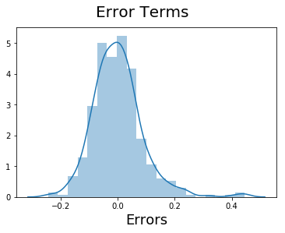

Step 8: Making Predictions Using the Final Model¶
Now that we have fitted the model and checked the normality of error terms, it's time to go ahead and make predictions using the final, i.e. fourth model.

Applying the scaling on the test sets¶
In [59]:
num_vars = ['area', 'bedrooms', 'bathrooms', 'stories', 'parking','price']

df_test[num_vars] = scaler.transform(df_test[num_vars])
In [60]:
df_test.describe()
Out[60]:
 | price | area | bedrooms | bathrooms | stories | mainroad | guestroom | basement | hotwaterheating | airconditioning | parking | prefarea | semi-furnished | unfurnished
count | 164.000000 | 164.000000 | 164.000000 | 164.000000 | 164.000000 | 164.000000 | 164.000000 | 164.000000 | 164.000000 | 164.000000 | 164.000000 | 164.000000 | 164.000000 | 164.000000
mean | 0.263176 | 0.298548 | 0.408537 | 0.158537 | 0.268293 | 0.865854 | 0.195122 | 0.347561 | 0.030488 | 0.353659 | 0.205285 | 0.237805 | 0.420732 | 0.329268
std | 0.172077 | 0.211922 | 0.147537 | 0.281081 | 0.276007 | 0.341853 | 0.397508 | 0.477654 | 0.172452 | 0.479569 | 0.289322 | 0.427043 | 0.495189 | 0.471387
min | 0.006061 | -0.016367 | 0.200000 | 0.000000 | 0.000000 | 0.000000 | 0.000000 | 0.000000 | 0.000000 | 0.000000 | 0.000000 | 0.000000 | 0.000000 | 0.000000
25% | 0.142424 | 0.148011 | 0.400000 | 0.000000 | 0.000000 | 1.000000 | 0.000000 | 0.000000 | 0.000000 | 0.000000 | 0.000000 | 0.000000 | 0.000000 | 0.000000
50% | 0.226061 | 0.259724 | 0.400000 | 0.000000 | 0.333333 | 1.000000 | 0.000000 | 0.000000 | 0.000000 | 0.000000 | 0.000000 | 0.000000 | 0.000000 | 0.000000
75% | 0.346970 | 0.397439 | 0.400000 | 0.500000 | 0.333333 | 1.000000 | 0.000000 | 1.000000 | 0.000000 | 1.000000 | 0.333333 | 0.000000 | 1.000000 | 1.000000
max | 0.909091 | 1.263992 | 0.800000 | 1.500000 | 1.000000 | 1.000000 | 1.000000 | 1.000000 | 1.000000 | 1.000000 | 1.000000 | 1.000000 | 1.000000 | 1.000000

Dividing into X_test and y_test¶
In [61]:
y_test = df_test.pop('price')
X_test = df_test
In [62]:
# Adding constant variable to test dataframe
X_test_m4 = sm.add_constant(X_test)
In [63]:
# Creating X_test_m4 dataframe by dropping variables from X_test_m4

X_test_m4 = X_test_m4.drop(["bedrooms", "semi-furnished", "basement"], axis = 1)
In [64]:
# Making predictions using the fourth model

y_pred_m4 = lr_4.predict(X_test_m4)

Step 9: Model Evaluation¶
Let's now plot the graph for actual versus predicted values.
In [65]:
# Plotting y_test and y_pred to understand the spread

fig = plt.figure()
plt.scatter(y_test, y_pred_m4)
fig.suptitle('y_test vs y_pred', fontsize = 20) # Plot heading
plt.xlabel('y_test', fontsize = 18) # X-label
plt.ylabel('y_pred', fontsize = 16)
Out[65]:
Text(0,0.5,'y_pred')
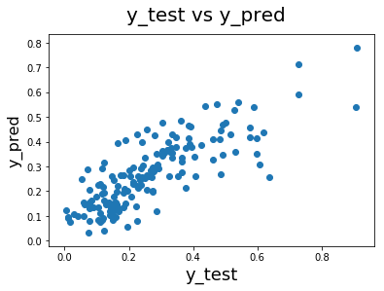
We can see that the equation of our best fitted line is:
price=0.236×area+0.202×bathrooms+0.11×stories+0.05×mainroad+0.04×guestroom+0.0876×hotwaterheating+0.0682×airconditioning+0.0629×parking+0.0637×prefarea−0.0337×unfurnishedprice=0.236×area+0.202×bathrooms+0.11×stories+0.05×mainroad+0.04×guestroom+0.0876×hotwaterheating+0.0682×airconditioning+0.0629×parking+0.0637×prefarea−0.0337×unfurnished
Overall we have a decent model, but we also acknowledge that we could do better.
We have a couple of options:
- Add new features (bathrooms/bedrooms, area/stories, etc.)
- Build a non-linear model

Model Selection using RFE (Housing Case Study)¶

Importing and Understanding Data¶
In [1]:
# Supress Warnings

import warnings
warnings.filterwarnings('ignore')
In [2]:
import pandas as pd
import numpy as np
In [3]:
# Importing Housing.csv
housing = pd.read_csv('Housing.csv')
In [4]:
# Looking at the first five rows
housing.head()
Out[4]:
 | price | area | bedrooms | bathrooms | stories | mainroad | guestroom | basement | hotwaterheating | airconditioning | parking | prefarea | furnishingstatus
0 | 13300000 | 7420 | 4 | 2 | 3 | yes | no | no | no | yes | 2 | yes | furnished
1 | 12250000 | 8960 | 4 | 4 | 4 | yes | no | no | no | yes | 3 | no | furnished
2 | 12250000 | 9960 | 3 | 2 | 2 | yes | no | yes | no | no | 2 | yes | semi-furnished
3 | 12215000 | 7500 | 4 | 2 | 2 | yes | no | yes | no | yes | 3 | yes | furnished
4 | 11410000 | 7420 | 4 | 1 | 2 | yes | yes | yes | no | yes | 2 | no | furnished

Data Preparation¶
In [5]:
# List of variables to map

varlist = ['mainroad', 'guestroom', 'basement', 'hotwaterheating', 'airconditioning', 'prefarea']

# Defining the map function
def binary_map(x):
return x.map({'yes': 1, "no": 0})

# Applying the function to the housing list
housing[varlist] = housing[varlist].apply(binary_map)
In [6]:
# Check the housing dataframe now

housing.head()
Out[6]:
 | price | area | bedrooms | bathrooms | stories | mainroad | guestroom | basement | hotwaterheating | airconditioning | parking | prefarea | furnishingstatus
0 | 13300000 | 7420 | 4 | 2 | 3 | 1 | 0 | 0 | 0 | 1 | 2 | 1 | furnished
1 | 12250000 | 8960 | 4 | 4 | 4 | 1 | 0 | 0 | 0 | 1 | 3 | 0 | furnished
2 | 12250000 | 9960 | 3 | 2 | 2 | 1 | 0 | 1 | 0 | 0 | 2 | 1 | semi-furnished
3 | 12215000 | 7500 | 4 | 2 | 2 | 1 | 0 | 1 | 0 | 1 | 3 | 1 | furnished
4 | 11410000 | 7420 | 4 | 1 | 2 | 1 | 1 | 1 | 0 | 1 | 2 | 0 | furnished

Dummy Variables¶
The variable furnishingstatus has three levels. We need to convert these levels into integer as well. For this, we will use something called dummy variables.
In [7]:
# Get the dummy variables for the feature 'furnishingstatus' and store it in a new variable - 'status'

status = pd.get_dummies(housing['furnishingstatus'])

# Check what the dataset 'status' looks like
status.head()
Out[7]:
 | furnished | semi-furnished | unfurnished
0 | 1 | 0 | 0
1 | 1 | 0 | 0
2 | 0 | 1 | 0
3 | 1 | 0 | 0
4 | 1 | 0 | 0
Now, you don't need three columns. You can drop the furnished column, as the type of furnishing can be identified with just the last two columns where —
- 00 will correspond to furnished
- 01 will correspond to unfurnished
- 10 will correspond to semi-furnished
In [8]:
# Let's drop the first column from status df using 'drop_first = True'
status = pd.get_dummies(housing['furnishingstatus'], drop_first = True)

# Add the results to the original housing dataframe
housing = pd.concat([housing, status], axis = 1)

# Now let's see the head of our dataframe.
housing.head()
Out[8]:
 | price | area | bedrooms | bathrooms | stories | mainroad | guestroom | basement | hotwaterheating | airconditioning | parking | prefarea | furnishingstatus | semi-furnished | unfurnished
0 | 13300000 | 7420 | 4 | 2 | 3 | 1 | 0 | 0 | 0 | 1 | 2 | 1 | furnished | 0 | 0
1 | 12250000 | 8960 | 4 | 4 | 4 | 1 | 0 | 0 | 0 | 1 | 3 | 0 | furnished | 0 | 0
2 | 12250000 | 9960 | 3 | 2 | 2 | 1 | 0 | 1 | 0 | 0 | 2 | 1 | semi-furnished | 1 | 0
3 | 12215000 | 7500 | 4 | 2 | 2 | 1 | 0 | 1 | 0 | 1 | 3 | 1 | furnished | 0 | 0
4 | 11410000 | 7420 | 4 | 1 | 2 | 1 | 1 | 1 | 0 | 1 | 2 | 0 | furnished | 0 | 0
In [9]:
# Drop 'furnishingstatus' as we have created the dummies for it
housing.drop(['furnishingstatus'], axis = 1, inplace = True)

housing.head()
Out[9]:
 | price | area | bedrooms | bathrooms | stories | mainroad | guestroom | basement | hotwaterheating | airconditioning | parking | prefarea | semi-furnished | unfurnished
0 | 13300000 | 7420 | 4 | 2 | 3 | 1 | 0 | 0 | 0 | 1 | 2 | 1 | 0 | 0
1 | 12250000 | 8960 | 4 | 4 | 4 | 1 | 0 | 0 | 0 | 1 | 3 | 0 | 0 | 0
2 | 12250000 | 9960 | 3 | 2 | 2 | 1 | 0 | 1 | 0 | 0 | 2 | 1 | 1 | 0
3 | 12215000 | 7500 | 4 | 2 | 2 | 1 | 0 | 1 | 0 | 1 | 3 | 1 | 0 | 0
4 | 11410000 | 7420 | 4 | 1 | 2 | 1 | 1 | 1 | 0 | 1 | 2 | 0 | 0 | 0

Splitting the Data into Training and Testing Sets¶
In [10]:
from sklearn.model_selection import train_test_split

# We specify this so that the train and test data set always have the same rows, respectively

df_train, df_test = train_test_split(housing, train_size = 0.7, test_size = 0.3, random_state = 100)

Rescaling the Features¶
We will use MinMax scaling.
In [11]:
from sklearn.preprocessing import MinMaxScaler
scaler = MinMaxScaler()
In [12]:
# Apply scaler() to all the columns except the 'yes-no' and 'dummy' variables
num_vars = ['area', 'bedrooms', 'bathrooms', 'stories', 'parking','price']

df_train[num_vars] = scaler.fit_transform(df_train[num_vars])

df_train.head()
Out[12]:
 | price | area | bedrooms | bathrooms | stories | mainroad | guestroom | basement | hotwaterheating | airconditioning | parking | prefarea | semi-furnished | unfurnished
359 | 0.169697 | 0.155227 | 0.4 | 0.0 | 0.000000 | 1 | 0 | 0 | 0 | 0 | 0.333333 | 0 | 0 | 1
19 | 0.615152 | 0.403379 | 0.4 | 0.5 | 0.333333 | 1 | 0 | 0 | 0 | 1 | 0.333333 | 1 | 1 | 0
159 | 0.321212 | 0.115628 | 0.4 | 0.5 | 0.000000 | 1 | 1 | 1 | 0 | 1 | 0.000000 | 0 | 0 | 0
35 | 0.548133 | 0.454417 | 0.4 | 0.5 | 1.000000 | 1 | 0 | 0 | 0 | 1 | 0.666667 | 0 | 0 | 0
28 | 0.575758 | 0.538015 | 0.8 | 0.5 | 0.333333 | 1 | 0 | 1 | 1 | 0 | 0.666667 | 0 | 0 | 1

Dividing into X and Y sets for the model building¶
In [13]:
y_train = df_train.pop('price')
X_train = df_train

Building our model¶
This time, we will be using the LinearRegression function from SciKit Learn for its compatibility with RFE (which is a utility from sklearn)

RFE¶
Recursive feature elimination
In [14]:
# Importing RFE and LinearRegression
from sklearn.feature_selection import RFE
from sklearn.linear_model import LinearRegression
In [15]:
# Running RFE with the output number of the variable equal to 10
lm = LinearRegression()
lm.fit(X_train, y_train)

rfe = RFE(lm, 10) # running RFE
rfe = rfe.fit(X_train, y_train)
In [16]:
list(zip(X_train.columns,rfe.support_,rfe.ranking_))
Out[16]:
[('area', True, 1),
('bedrooms', True, 1),
('bathrooms', True, 1),
('stories', True, 1),
('mainroad', True, 1),
('guestroom', True, 1),
('basement', False, 3),
('hotwaterheating', True, 1),
('airconditioning', True, 1),
('parking', True, 1),
('prefarea', True, 1),
('semi-furnished', False, 4),
('unfurnished', False, 2)]
In [17]:
col = X_train.columns[rfe.support_]
col
Out[17]:
Index(['area', 'bedrooms', 'bathrooms', 'stories', 'mainroad', 'guestroom',
'hotwaterheating', 'airconditioning', 'parking', 'prefarea'],
dtype='object')
In [18]:
X_train.columns[~rfe.support_]
Out[18]:
Index(['basement', 'semi-furnished', 'unfurnished'], dtype='object')

Building model using statsmodel, for the detailed statistics¶
In [19]:
# Creating X_test dataframe with RFE selected variables
X_train_rfe = X_train[col]
In [20]:
# Adding a constant variable
import statsmodels.api as sm
X_train_rfe = sm.add_constant(X_train_rfe)
In [21]:
lm = sm.OLS(y_train,X_train_rfe).fit() # Running the linear model
In [22]:
#Let's see the summary of our linear model
print(lm.summary())
OLS Regression Results
==============================================================================
Dep. Variable: price R-squared: 0.669
Model: OLS Adj. R-squared: 0.660
Method: Least Squares F-statistic: 74.89
Date: Tue, 09 Oct 2018 Prob (F-statistic): 1.28e-82
Time: 13:15:31 Log-Likelihood: 374.65
No. Observations: 381 AIC: -727.3
Df Residuals: 370 BIC: -683.9
Df Model: 10
Covariance Type: nonrobust
===================================================================================
coef std err t P>|t| [0.025 0.975]
-----------------------------------------------------------------------------------
const 0.0027 0.018 0.151 0.880 -0.033 0.038
area 0.2363 0.030 7.787 0.000 0.177 0.296
bedrooms 0.0661 0.037 1.794 0.074 -0.006 0.139
bathrooms 0.1982 0.022 8.927 0.000 0.155 0.242
stories 0.0977 0.019 5.251 0.000 0.061 0.134
mainroad 0.0556 0.014 3.848 0.000 0.027 0.084
guestroom 0.0381 0.013 2.934 0.004 0.013 0.064
hotwaterheating 0.0897 0.022 4.104 0.000 0.047 0.133
airconditioning 0.0711 0.011 6.235 0.000 0.049 0.093
parking 0.0637 0.018 3.488 0.001 0.028 0.100
prefarea 0.0643 0.012 5.445 0.000 0.041 0.088
==============================================================================
Omnibus: 86.105 Durbin-Watson: 2.098
Prob(Omnibus): 0.000 Jarque-Bera (JB): 286.069
Skew: 0.992 Prob(JB): 7.60e-63
Kurtosis: 6.753 Cond. No. 13.2
==============================================================================

Warnings:
[1] Standard Errors assume that the covariance matrix of the errors is correctly specified.
Bedrooms is insignificant in presence of other variables; can be dropped
In [23]:
X_train_new = X_train_rfe.drop(["bedrooms"], axis = 1)
Rebuilding the model without bedrooms
In [24]:
# Adding a constant variable
import statsmodels.api as sm
X_train_lm = sm.add_constant(X_train_new)
In [25]:
lm = sm.OLS(y_train,X_train_lm).fit() # Running the linear model
In [26]:
#Let's see the summary of our linear model
print(lm.summary())
OLS Regression Results
==============================================================================
Dep. Variable: price R-squared: 0.666
Model: OLS Adj. R-squared: 0.658
Method: Least Squares F-statistic: 82.37
Date: Tue, 09 Oct 2018 Prob (F-statistic): 6.67e-83
Time: 13:15:31 Log-Likelihood: 373.00
No. Observations: 381 AIC: -726.0
Df Residuals: 371 BIC: -686.6
Df Model: 9
Covariance Type: nonrobust
===================================================================================
coef std err t P>|t| [0.025 0.975]
-----------------------------------------------------------------------------------
const 0.0242 0.013 1.794 0.074 -0.002 0.051
area 0.2367 0.030 7.779 0.000 0.177 0.297
bathrooms 0.2070 0.022 9.537 0.000 0.164 0.250
stories 0.1096 0.017 6.280 0.000 0.075 0.144
mainroad 0.0536 0.014 3.710 0.000 0.025 0.082
guestroom 0.0390 0.013 2.991 0.003 0.013 0.065
hotwaterheating 0.0921 0.022 4.213 0.000 0.049 0.135
airconditioning 0.0710 0.011 6.212 0.000 0.049 0.094
parking 0.0669 0.018 3.665 0.000 0.031 0.103
prefarea 0.0653 0.012 5.513 0.000 0.042 0.089
==============================================================================
Omnibus: 91.542 Durbin-Watson: 2.107
Prob(Omnibus): 0.000 Jarque-Bera (JB): 315.402
Skew: 1.044 Prob(JB): 3.25e-69
Kurtosis: 6.938 Cond. No. 10.0
==============================================================================

Warnings:
[1] Standard Errors assume that the covariance matrix of the errors is correctly specified.
In [27]:
X_train_new.columns
Out[27]:
Index(['const', 'area', 'bathrooms', 'stories', 'mainroad', 'guestroom',
'hotwaterheating', 'airconditioning', 'parking', 'prefarea'],
dtype='object')
In [28]:
X_train_new = X_train_new.drop(['const'], axis=1)
In [29]:
# Calculate the VIFs for the new model
from statsmodels.stats.outliers_influence import variance_inflation_factor

vif = pd.DataFrame()
X = X_train_new
vif['Features'] = X.columns
vif['VIF'] = [variance_inflation_factor(X.values, i) for i in range(X.shape[1])]
vif['VIF'] = round(vif['VIF'], 2)
vif = vif.sort_values(by = "VIF", ascending = False)
vif
Out[29]:
 | Features | VIF
0 | area | 4.52
3 | mainroad | 4.26
2 | stories | 2.12
7 | parking | 2.10
6 | airconditioning | 1.75
1 | bathrooms | 1.58
8 | prefarea | 1.47
4 | guestroom | 1.30
5 | hotwaterheating | 1.12

Residual Analysis of the train data¶
So, now to check if the error terms are also normally distributed (which is infact, one of the major assumptions of linear regression), let us plot the histogram of the error terms and see what it looks like.
In [30]:
y_train_price = lm.predict(X_train_lm)
In [31]:
# Importing the required libraries for plots.
import matplotlib.pyplot as plt
import seaborn as sns
%matplotlib inline
In [32]:
# Plot the histogram of the error terms
fig = plt.figure()
sns.distplot((y_train - y_train_price), bins = 20)
fig.suptitle('Error Terms', fontsize = 20) # Plot heading
plt.xlabel('Errors', fontsize = 18) # X-label
C:\Users\admin\Anaconda3\lib\site-packages\matplotlib\axes\_axes.py:6462: UserWarning: The 'normed' kwarg is deprecated, and has been replaced by the 'density' kwarg.
warnings.warn("The 'normed' kwarg is deprecated, and has been "
Out[32]:
Text(0.5,0,'Errors')
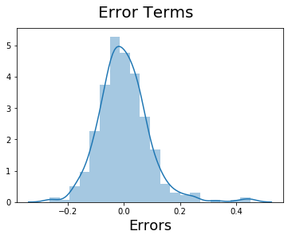

Making Predictions¶

Applying the scaling on the test sets¶
In [33]:
num_vars = ['area', 'bedrooms', 'bathrooms', 'stories', 'parking','price']

df_test[num_vars] = scaler.transform(df_test[num_vars])

Dividing into X_test and y_test¶
In [34]:
y_test = df_test.pop('price')
X_test = df_test
In [35]:
# Now let's use our model to make predictions.

# Creating X_test_new dataframe by dropping variables from X_test
X_test_new = X_test[X_train_new.columns]

# Adding a constant variable
X_test_new = sm.add_constant(X_test_new)
In [36]:
# Making predictions
y_pred = lm.predict(X_test_new)

Model Evaluation¶
In [1]:
# Plotting y_test and y_pred to understand the spread.
fig = plt.figure()
plt.scatter(y_test,y_pred)
fig.suptitle('y_test vs y_pred', fontsize=20) # Plot heading
plt.xlabel('y_test', fontsize=18) # X-label
plt.ylabel('y_pred', fontsize=16) # Y-label
---------------------------------------------------------------------------
NameError Traceback (most recent call last)
<ipython-input-1-cdd3830bd31f> in <module>
1 # Plotting y_test and y_pred to understand the spread.
----> 2 fig = plt.figure()
3 plt.scatter(y_test,y_pred)
4 fig.suptitle('y_test vs y_pred', fontsize=20) # Plot heading
5 plt.xlabel('y_test', fontsize=18) # X-label

NameError: name 'plt' is not defined
In [ ]:

